Sovren Resume Normalizer User Guide
Last updated: March 15, 2016

Introduction
The Sovren Normalizer is offered as a .NET or SaaS API that uses user-editable files to control the output. The normalizer includes built-in normalization lists but you may also implement your own custom lists.

Normalizer Files
The Sovren Normalizer uses standard tab delimited text files to normalize terms.

PLEASE NOTE: We strongly recommend using the Sovren Normalizer Editor application (available in our downloads site) to create and maintain custom normalizer files. The application will take care of applying all the necessary settings, formats, and posting of your files to your SaaS account (if applicable) through a simple GUI.

PLEASE NOTE: These files are hand editable. If you deploy the Normalizer in multiple places, these files will be out of sync unless you copy the data files into every Data folder under every Normalizer location or configure all Normalizer instances to use a common Data folder.

PLEASE NOTE: You must edit and save the files in a Unicode-aware application and manner. We suggest Notepad. When saving the files in Notepad, you must choose File => Save As => and then change the encoding to UTF-8 before saving.

PLEASE NOTE: Back up the files before saving. Do NOT modify the file names, nor leave off the file extensions, nor rename the Data folder.

PLEASE NOTE: If you are using the installed API and make changes to the files while the application containing the Normalizer class is still running, you will either need to restart the application or call Normalizer.ClearDataCache for the changes to take effect.

Here are the files that are used and what they mean:

SN.COMPANY.ALL.txt
Contains the normalized company name and then the raw company name, separated by a single tab and only by a single tab. For example, the following company names will all get normalized to “Amazon”:

Amazon Amazon.co.uk
Amazon Amazon.com
Amazon Amazon.com Inc.
Amazon Amazon.com, Inc

SN.COMPANY_DQ_ANYWHERE.ALL.txt
Contains the normalized company name and then the disqualifier word or phrase, separated by a single tab and only by a single tab. If the disqualifier word or phrase appears ANYWHERE in the resume, it will prevent the company name from being normalized to the value shown. For example, the following company names will not get normalized to “Amazon Web Services” if the term to the right appears anywhere in the resume:

Amazon Web Services Allied Waste Services
Amazon Web Services Allied Waste
Amazon Web Services Waste Services

SN.COMPANY_DQ_IN_NAME.ALL.txt
Contains the normalized company name and then the disqualifier word or phrase, separated by a single tab and only by a single tab. If the disqualifier word or phrase appears ANYWHERE in the company name, it will prevent the company name from being normalized to the value shown. For example, the following terms will not get normalized to “Amazon” if the term to the right appears anywhere in the company name:

Amazon Amazon Floral Services
Amazon Amazon Landscaping

SN.POSITION_TITLE_SYNONYMS.ALL.txt
Contains the normalized job title word or phrase and then the job title synonym, separated by a single tab and only by a single tab. For example, the following titles will get normalized to “VP”:

VP Vice Pres
VP Vice Pres.
VP Vice President

SN.SCHOOL.ALL.txt
Contains the normalized school name and then the raw school name, separated by a single tab and only by a single tab. For example, the following school names will get normalized to “California Institute of Technology”:

California Institute of Technology California Institute of Technology Pasadena
California Institute of Technology California Institute of Technology-United States-CA
California Institute of Technology Caltech
California Institute of Technology Southern California Institute of Technology

SN.SCHOOL_DQ_ANYWHERE.ALL.txt
Contains the normalized school name and then the disqualifier word or phrase, separated by a single tab and only by a single tab. If the disqualifier word or phrase appears ANYWHERE in the resume, it will prevent the school name from being normalized to the value shown. For example, the following school names will not get normalized to “California Institute of Technology” if the term to the right appears anywhere in the resume:

California Institute of Technology California Technology School
California Institute of Technology California School of Technology

SN.SCHOOL_DQ_IN_NAME.ALL.txt
Contains the normalized school name and then the disqualifier word or phrase, separated by a single tab and only by a single tab. If the disqualifier word or phrase appears ANYWHERE in the school name, it will prevent the school name from being normalized to the value shown. . For example, the following school names will not get normalized to “Harvard University” if the term to the right appears anywhere in the school name:

Harvard University Harvard Technical College
Harvard University Harvard Community College

SN.SCHOOL_SYNONYMS.ALL.txt
Contains the normalized school word or phrase and then the school synonym, separated by a single tab and only by a single tab. These synonyms are applied to a raw school name to produce one of the standardized variations of the school name used to find a matching entry in SN.SCHOOL.ALL.txt. If a match is not found in the SCHOOL list, then these synonym substitutions are applied to the dynamic normalized value. For example, the following terms will all get normalized to “University”:

University U
University U.
University UNIV
University UNIV.

SN.DEGREE.ALL.txt
Contains the normalized degree name and then the raw degree name, separated by a single tab and only by a single tab. For example, the following degree names will get normalized to “Bachelors”:

Bachelors B. A
Bachelors B. A.
Bachelors Bachelors of Arts

SN.STRIP_FROM_COMPANY_NAME.ALL.txt
Contains words which will be stripped from the company names. For example, the following terms will be removed from company names if found:

& CO
& CO.
& COMPANY

SN.STRIP_FROM_SCHOOL_NAME.ALL.txt
Contains words which will be stripped from the school names. For example, the following terms will be removed from school names if found:

Inc.
Incorporated
Corp.

SN.SCHOOL_AQ_ANYWHERE.ALL.txt
Not used.

SN.COMPANY_AQ_ANYWHERE.ALL.txt
Not used.

.NET API

IMPORTANT: The Normalizer’s .NET API will only work with versions of the Sovren Resume Parser 7.5.7500.2 and higher. Please verify the version of your SrpAllInOne.dll file (right-click on the file and go to Properties -> Details) before using the Normalizer.

If you are using the installed .NET API, you may implement custom normalization files by specifying the NormalizerSettings.DataFolder property or the Sovren.NormalizerSettings.DataFolder app setting in your configuration file. You may also set this through the DataFolder property of the NormalizerSettings object. Alternatively, you may compress all your Normalizer files into a .zip archive and pass it through the CustomDataSource property of the NormalizerSettings object as a byte array. Otherwise, the default behavior is for the built-in Sovren Normalizer lists be used for normalization.

<appSettings>
<!-- Path to Sovren normalizer lists -->
<add key="Sovren.NormalizerSettings.DataFolder" value="C:\MyLists"/>
</appSettings>

To implement custom normalization lists, you can use the Sovren Normalization Editor app. To normalize an HR-XML file:

string file = @"MyHrXmlResume.xml";
string xmlText = FileHelper.ReadAllText(file);
Normalizer normalizer = new Normalizer(new NormalizerSettings(
{
PreserveApostrophes = true,
PreserveExistingNormalizedValues = true
});
string normalizedText = normalizer.Normalize(xmlText);
To normalize an instance of the hrxmlResume class:
string file = @"MyHrXmlResume.xml";
string xmlText = FileHelper.ReadAllText(file);
hrxmlResume resume = new hrxmlResume(new ParserSettings());
resume.LoadXml(xmlText);
Normalizer normalizer = new Normalizer(new NormalizerSettings(
{
PreserveApostrophes = true,
PreserveExistingNormalizedValues = true
});
normalizer.Normalize(resume);
// Optionally, extract the normalized HR-XML
string xmlTextNormalized = resume.GetAsXml();
The Normalizer component contains methods to normalize specific types of data individually rather than an entire parsed resume. Please note that these methods require that the entire text of the resume be passed in the "xmlText" parameter.
SaaS API
If you are using the SaaS API, you may normalize resume at parse time by setting the NormalizerData field of the ParseResumeRequest (see API documentation for more info). Additionally, if you already have existing HR-XML, you may call the NormalizeResume web method to normalize it (Note: each data normalization transaction costs .1 credits).
The syntax for the NormalizerData field is as follows:
NormalizerData = NormalizerDataName
NormalizerDataName = "builtin" | the name you gave to your group of custom normalizer files
Sample use cases:
NormalizerData="builtin"
Uses built-in Sovren normalization lists (English only)
NormalizerData="MyCustomNormalizerData"
Uses custom contextual normalization data
HR-XML Output
Whenever a call to normalize a resume is performed, the results will be displayed in the <UserArea> section of the entity that is being normalized (i.e. company name, school name, etc.). The following XML section displays a normalized company name (from “Cisco Systems, Inc” to “Cisco”):
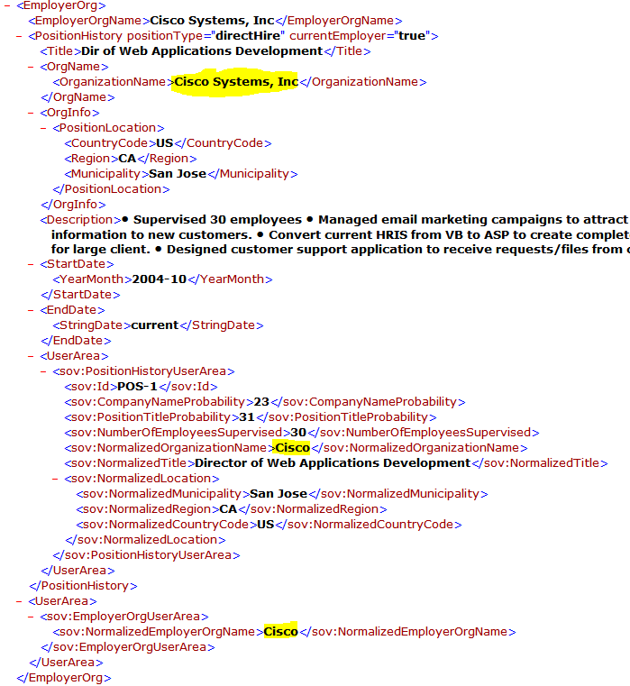

For more information about the HR-XML schema definition and where you can expect to see normalized values, please review the Sovren HR-XML Resume Guide and the SovrenResumeExtensions.xsd file included in it.

